Project Title,

CALCULATE TRIPCOST

**Contents**: -

**1: Introduction**

1.1: Scope

1.2: Intended audience

**2.Source File**

2.1: Filename

2.2: Source File Structure

2.3: Indentation

2.4: Naming Convection

2.5: Comments

**3.Exception Handling**

**4.Tools and Plugins**

**Introduction**

For making the site reliable, scalable, accessible, and sustainable Quality Assurance (QA) team must adopt and maintain the coding standards which allows code readability and makes it easier to understand.

TripAdvisor is the World’s largest travel platform. The website offers online hotel reservations and bookings- for transportation, lodging, travel experiences, and restaurants.

**Problem Statement: Calculate Trip Cost**

Display total amount and charges per night for 3 holiday homes:

1. For 4 people in Nairobi from 20-th Mar-2023to 24-th Mar-2023
2. Sort the list with highest traveller rating on top.
3. Holiday home should have elevator/ Lift Access.

(Suggested Site: tripadvisor.in however you are free to choose any other legitimate  site)+B6

**Detailed Description:**

1. Display Hotel name, total amount and charges per night for 3 holiday homes for 4 people in Nairobi for 5 days of stay from tomorrow's date; Should have sorted the list with highest traveler rating & should have elevator/ List  access  
2 Pick one cruise line & pick a respective cruise ship under Cruises;   
                a. Retrieve all the languages offered and store in a List; Display the same  
                b. Display passengers, crew & launched year  
(Suggested Site: tripadvisor.in however  you are free to choose any other legitimate  site)

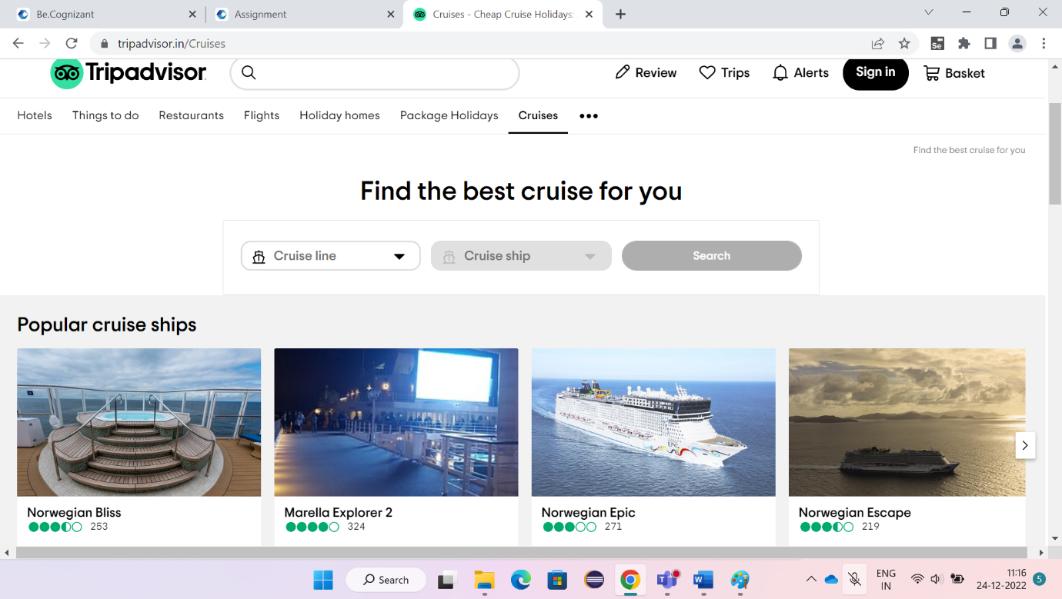1.1: Scope:

The practices of targeted towards code readability and maintenance of coding standards , maintaining standard Indentation, and naming conventions which demonstrate the knowledge of Professionalism.

1. Writing java code that is easy to maintain and easy for demonstrations.
2. Increase code usability.

**Key Automation Scope**

* Handling different browser windows, search option
* Validation of date controls
* Capture warning message
* Extract list items & store in collections
* Navigating back to home page
* Scrolling down in web page

1.2: Intended audience

Business Unit (Bu) SME

coach

Technical Trainer

**Source File**

The header should be followed by the package and import statement and then the document comments exactly in the following sequence and indented to the same level.

2.1: Filename

The source file name consists of the case-sensitive name of the top-level class it contains, plus the java extension.

2.2: Source File Structure

A source file consists of, in order:

* Package Name
* Imports
* Class definitions

2.3: Indentation

* There must be a space after giving a comma between two function arguments.
* Proper indentation should be there at the beginning and end of each block in the program.
* All braces should start from a new line and the code following the end of braces should also start from a new line.

2.4: Naming Convention

* Local variables and Global variables should be named using camel case lettering starting with a small letter (e.g., local Data).
* Constant Data should be named using upper case letters only. (e.g., CONSTDATA).
* Avoid use of digits for naming variables.
* The names of functions should be written in camel case starting

The name of the function must describe the use of the function.

2.5: Comments

**Block comments** may be used at the beginning of each file and before each method or within methods. A block comment should have a blank line before its start.

**Single-line comments** can appear on a single line indented to the level of the level of that follows. If a comment cannot be written in a single line, it should follow the block comment should be preceded by a blank line.

3: Exception Handling

You must follow the below Java coding guidelines for implementing effective exception handling.

1-Always write a catch block for handling exceptions.

2-Make sure to add a logging message or the stack trace in the catch block.

3-Avoid catching the general exception and have a specific exception.

4-The clean-up code should be added in the <finally> block.

5-This provides a unique location for the clean-up, and it is guaranteed to run.

**4: Tools and Plugins**

## 1.Selenium with Java

Selenium is the first thing that comes to mind when one is planning to automate the testing of web application. Selenium is a beneficial tool because it is not only open source but also a portable software testing framework for web applications that support multiple languages like Java, C#, Ruby, Python. Choosing the right language depends on the application under test, the supporting community, available test automation frameworks, usability, elegance, and of course, seamless build integration.

• Java is a popular programming language. As per Stack Overflow, itis the third most popular back-end technology after JavaScript and SQL.

• A good community of developers to create documentation and resolve issues has helped Java to become the most preferred language among the application developers. Thus, writing selenium test cases using Java has multiple benefits:

**2.Maven**

• Maven's primary goal is to allow a developer to comprehend the complete state of a development effort in the shortest period. To attain this goal, Maven deals with several areas of concern:

• Making the build process easy

• Providing a uniform build system

• Providing quality project information

• Encouraging better development practices

**3.TestNG**

TestNG is an open-source test automation framework for Java. It is developed on the same lines of J-Unit and N-Unit. Few advanced and useful features provided by TestNG makes it a more robust framework compared to its peers. The NG in TestNG stands for 'Next Generation'.

**4.Apache POI**

Apache POI is a popular API that allows programmers to create, modify, and display MS Office files using Java programs. It is an open-source library developed and distributed by Apache Software Foundation to design or modify Microsoft Office files using Java program.

**5.POM**

A Project Object Model or POM is the fundamental unit of work in Maven. It is an XML file that contains information about the project and configuration details used by Maven to build the project. It contains default values for most projects. Examples for this is the build directory, which is target; the source directory, which is src/main/java; the test source directory, which is src/test/java; and so on. When executing a task or goal, Maven looks for the POM in the current directory. It reads the POM, gets the needed configuration information, then executes the goal. Some of the configuration that can be specified in the POM are the project dependencies, the plugins or goals that can be executed, the build profiles, and so on. Other information such as the project version, description, developers, mailing lists and such can also be specified.

**6.Extent Reports**

Extent Reports is an open-source reporting library useful for test automation. It can be easily integrated with major testing frame works like J-Unit, N-Unit, TestNG, etc. These reports are HTML documents that depict results as pie charts. They also allow the generation of custom logs, snapshots, and other customized details. Once an automated test script runs successfully, testers need to generate a test execution report. While TestNG does provide a default report, they do not provide the details.

**7.Back up**

GitHub for Source Code Management & Backup. GitHub is a code hosting platform for version control and collaboration. It lets you and others work together on projects from anywhere.